Name:

HOMEWORK 3
The Z-table and the Correlation Coefficient (r)
1. | (20 points) The results from a statistics class’ first exam are as follows: The average grade obtained on the exam by its 25 students is an 83, with a standard deviation of 11 points. Answer the following based on this information:  Approximately how many people received a failing grade (less than 65)?  μ=83, σ=11, n=25, x = 65  Thus the P(x≤65)  Therefore  Z = (x – μ)/ 25^{1/2}  Z= 65-83/5 = -8.1818  Therefore from the z tables  P(x≤65) = P(Z≤ -8.1818) = 0.0509  The probability of failing is 0.0509  The number of people who failed the test = 25*0.0509  = 1.2725  Thus, approximately 2 people received a failing grade.  b. What percentage of people received a grade between a 70 and a 91?  μ=83, σ=11, n=25, x = 65  Thus the P70≤(x≤90)  Therefore  Z1 = (x – μ)/ 25^{1/2}  Z= 70-83/5 = -8.1818  Z1 = -5.9091  Z2 = (90 – 83)/ 25^{1/2}  Z2 = 3.6364  Therefore from the z tables  P(z≤ -8.1818) - P(Z≤ 3.6364) = 0.999 – 0  0.6478  The percentage of people who received a grade between 70 and 90 = 64.8%  c. What percentage of individuals received a score whose z-score was -.70 or less?  1 – P (z≤ -0.7)  =0.758  1 – 0.758  = 0.2420  Individuals who received a score whose z score = -0.7 = 24.2%  d. What grade is required in order to be in the top 15 percent? The top 10 percent?  The grade required to be in the top 15% is 94.4%  The grade required to be in top 10% is 97.19  e. What percentage of people received a grade between 85 and 95?  Pr(Z≤5.4545)− Pr(Z≤0.9091) = 1−0.8183=0.2902  Therefore the percentage of people who received between 85 and 95 = 29%  f. What percentage of people received a grade of 94 or less?  P(x≤94) = P(Z≤ 5) = 0.8413  Therefore the percentage of people received a grade of 94 or less = 84.13%  g. What grade is required to be in the bottom 20%?  The bottom 20% grade is 73.65 or below  h. What z-score is required to be in the top 40%?  The Z-score required = 0.26  - What percentage of individuals have a z-score between -1 and 1.40?  =76.05%  j. What percentage of individuals have a z-score between 1.05 and 1.40?  = 6.61%
2. | (12 pts) An ethologist is interested in how long it takes a certain species of water shrew to catch its prey. He only has access to a sample of 100 shrews. On multiple occasions each day he lets a dragonfly loose inside the cage of the shrews and times how long it takes until the shrews catch the dragonfly. After months of research the ethologist concludes 1) that the mean prey catching time was 30 seconds, 2) the standard deviation was 5.5 seconds and 3) that the scores he has collected are normally distributed. What is the percentage of shrews that:  - catch a dragonfly in less than 18 seconds;  P(x≤18)= -2.18  - catch a dragonfly in between 22 and 45 seconds;  = 92.32%  - take longer than 45 seconds to catch a dragonfly?  = 0.33%  - take less than 30 seconds to catch its prey;  = 50%
3. | (8 pts) The following is known about the weights of a sample of 31 people.  Σx = 4870  Σx²= 808450
  - Find SS
  = 43,388.71
  - Find s²
  = 1446.28
  - Find s
  = 38.03
  - Find
  = 157.09
4. | (20 pts) SPSS Question: A farmer would like to evaluate the effectiveness of his harvesting techniques by examining the crop yield in a few of his plots of land where he grows both strawberries and tomatoes. The data below contains a column for each fruit type (strawberries and tomatoes), and represents the number of pounds collected from those plots each month across a span of 12 months. The data set also contains a column for the average amount of rain (in inches) and days of sunlight per month.  Month Strawb Tomato Rain Sun  Jan 3.00 21.00 6.00 21.00  Feb 2.00 24.00 4.00 25.00  Mar 5.00 20.00 10.00 21.00  Apr 2.00 27.00 4.00 28.00  May 1.00 17.00 2.00 18.00  June 2.00 18.00 4.00 19.00  July 4.00 27.00 8.00 28.00  Aug 4.00 21.00 8.00 22.00  Sept 2.00 21.00 4.00 22.00  Oct 3.00 18.00 5.00 19.00  Nov 1.00 10.00 2.00 11.00  Dec 6.00 10.00 12.00 18.00  Please answer the following questions based on this data set and include the appropriate tables and/or graphs where required.  - Using SPSS, compute the mean and standard deviation of the pounds of tomatoes and strawberries grown for the whole year. Paste this data table here. Based on this data, which plot produced more fruit?  Based on the data the tomato plot produced more fruit  - The farmer knows that in December he introduced a special plant fertilizer to both soils. He notices that his farm produced 6 pounds of strawberries and 10 pounds of tomatoes in December. He concludes that the fertilizer worked more for the tomatoes than the strawberries. Is this a correct conclusion? Explain in detail why or why not. (If it is correct, point out what aspects of this data set would lead you to agree with the farmer. If it is not correct, provide the adequate analysis and solution.)  The decision that the farmers is making is incorrect since when evaluating the produce for both tomatoes and strawberries, the trwaberry data remains consistently low when compared to tomatoes and thus the introduction of special plant fertilizer cannot be the basis in explaining the difference.  - The farmer would like to know whether or not there is a relationship between the amount of rainfall during the month and the crop yield it produces. Include a table and accompanying graph from SPSS that displays the statistic which describe the RELATIONSHIP between:  - rainfall and strawberries produced  There is a strong positive relationship between rainfall and strawberries produced  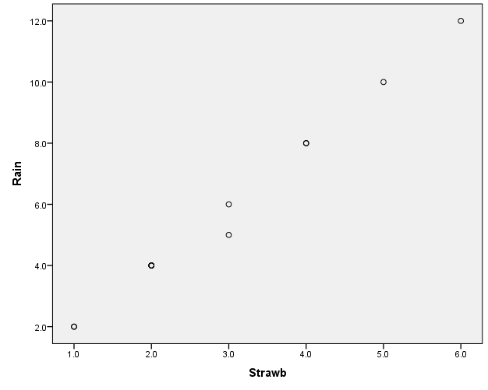  - rainfall and tomatoes produced  There is no relationship between rainfall and tomatoes produced  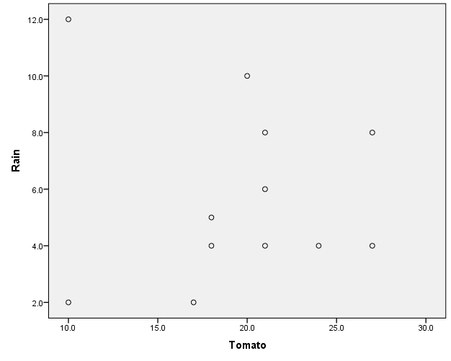  - sunlight and strawberries produced  There is no relationship between sunlight and strawberries  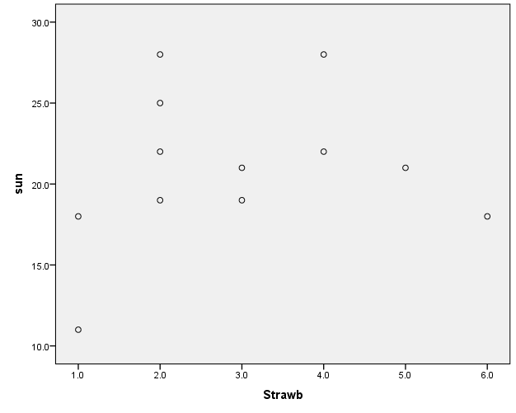  - sunlight and tomatoes produced  There is a strong positive relationship between sunlight and tomatoes produced.  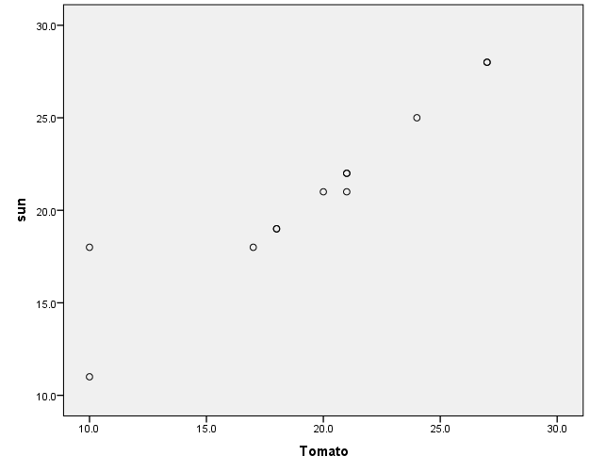  - explain your results. Is it possible that these two crop types respond differentially to the environment? Yes. The crops production increased in the different environments.  - Are there any factors which could be contributing to the amount of each type of fruit that is produced which the farmer has not yet considered?  The weight of the fruits, the soil, how much the fruits were taking care of, the amount of seeds that were planted.
  Statistics
   |  | Strawb | Tomato
  N | Valid | 12 | 12
  N | Missing | 0 | 0
  Mean |  | 2.917 | 19.500
  Std. Deviation |  | 1.5643 | 5.4855
  Correlations
   |  | Rain | Strawb
  Rain | Pearson Correlation | 1 | .996**
  Rain | Sig. (2-tailed) |  | .000
  Rain | N | 12 | 12
  Strawb | Pearson Correlation | .996** | 1
  Strawb | Sig. (2-tailed) | .000
  Strawb | N | 12 | 12
  **. Correlation is significant at the 0.01 level (2-tailed).
  Correlations
   |  | Rain | Tomato
  Rain | Pearson Correlation | 1 | -.061
  Rain | Sig. (2-tailed) |  | .851
  Rain | N | 12 | 12
  Tomato | Pearson Correlation | -.061 | 1
  Tomato | Sig. (2-tailed) | .851
  Tomato | N | 12 | 12
  Correlations
   |  | sun | Strawb
  sun | Pearson Correlation | 1 | .186
  sun | Sig. (2-tailed) |  | .563
  sun | N | 12 | 12
  Strawb | Pearson Correlation | .186 | 1
  Strawb | Sig. (2-tailed) | .563
  Strawb | N | 12 | 12
  Correlations
   |  | sun | Tomato
  sun | Pearson Correlation | 1 | .929**
  sun | Sig. (2-tailed) |  | .000
  sun | N | 12 | 12
  Tomato | Pearson Correlation | .929** | 1
  Tomato | Sig. (2-tailed) | .000
  Tomato | N | 12 | 12
  **. Correlation is significant at the 0.01 level (2-tailed).
5. | (10 pts) Suppose you have collected data (table at the right) from four of your friends on their head size (measured as centimeters around the head from the forehead) and their IQ.  Compute the correlation of the following set of numbers BY HAND and show your work. What do the value and sign of this correlation coefficient tell you. Explain the significance of the correlation between head size and intelligence as measured by IQ. (Do you believe it?) If you do not, what explanation can you provide?  Head size (X) Values  ∑ = 211  Mean = 52.75  ∑(X - M_{x})² = SS_{x} = 5573.875  IQ(Y) Values  ∑ = 448  Mean = 112  ∑(Y - M_{y})² = SS_{y} = 25336  X and Y Combined  N = 8  ∑(X - M_{x})(Y - M_{y}) = 11844  R Calculation  r = ∑((X - M_{y})(Y - M_{x})) / √((SS_{x})(SS_{y}))  r = 11844 / √((5573.875)(25336)) = 0.601  r = 0.9967  There is a positive strong relationship between head size and IQ  P –value = 0.399. The result is not significant at p < 0.05.
  Subject | Head Size | IQ
  1 | 53 | 120
  2 | 55 | 118
  3 | 51 | 110
  4 | 52 | 100
 | I think that there might be a relationship between head size and IQ although the sample size is very small which makes the findings suspicious and thus there is need for further tests.
6. | (5 pts) SPSS Question: Using the same data as in Problem 5, conduct a correlational analysis in SPSS (in other words, use SPSS to obtain the correlation coefficient). Paste your output here, it should be exactly the same value you calculated when you did it by hand. Then, graph a scatter plot of the data along with a line of best fit.  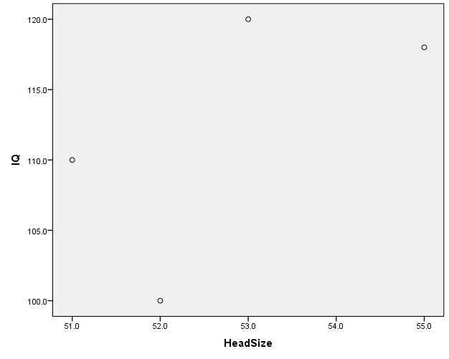
  Correlations
   |  | HeadSize | IQ
  HeadSize | Pearson Correlation | 1 | .601
  HeadSize | Sig. (2-tailed) |  | .399
  HeadSize | N | 4 | 4
  IQ | Pearson Correlation | .601 | 1
  IQ | Sig. (2-tailed) | .399
  IQ | N | 4 | 4

7. | (25 pts) For each of the following descriptions of regions of a population of test scores, shade in the described region and label the axes in whole-number z-score units, as well as their corresponding raw-score values. Shade in the region corresponding to scores which:
  a. | Fall between 75 and 90.  Z score of 75 = -1  Z score of 90 =2 | 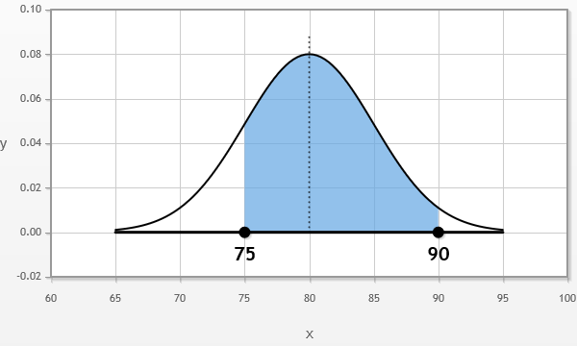 | μ = 80  σ = 5
   |  | Area of the shaded region (%): 81.9%
  b. | Have z-scores between 0 and 1.5  Raw score if z is 0 = - 5.71  Raw score if z is 1.5 = - 5.5 | 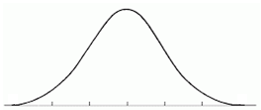 | μ = 40  σ = 7
   |  | Area of the shaded region (%): 0%
  . | Fall in the middle 30% of the distribution  Z score of the left limit = 0.7129  Z score of the right limit = 0.042  Raw score of the left limit = 78  Raw score of the right limit = 67 |  | μ = 50  σ = 8
   |  | Area of the shaded region (%):23.6%
  d. | Fall between 69 and 72  Z score of 69 = 1  Z score of 72 = 1.75 | 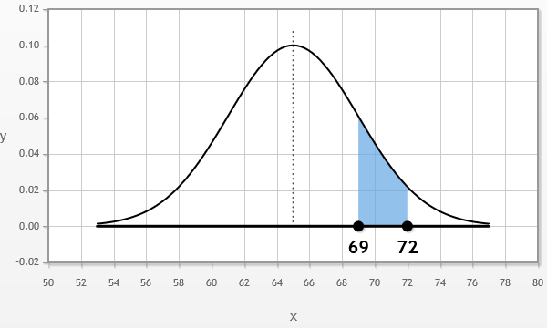 | μ = 65  σ = 4
   |  | Area of the shaded region (%): 11.86%
  e. | Fall below a score of  Z score of 67 = -1.18 | 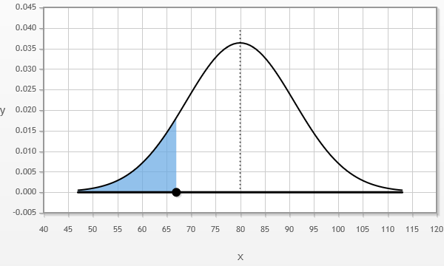 | μ = 80  σ = 11
   |  | Area of the shaded region (%):11.9%

